**Hannah Green**

**E21**

**Evidence of Project Unit**

**P 1 Take a screenshot of the contributor’s page on Github from your group project to show the team you worked with.**

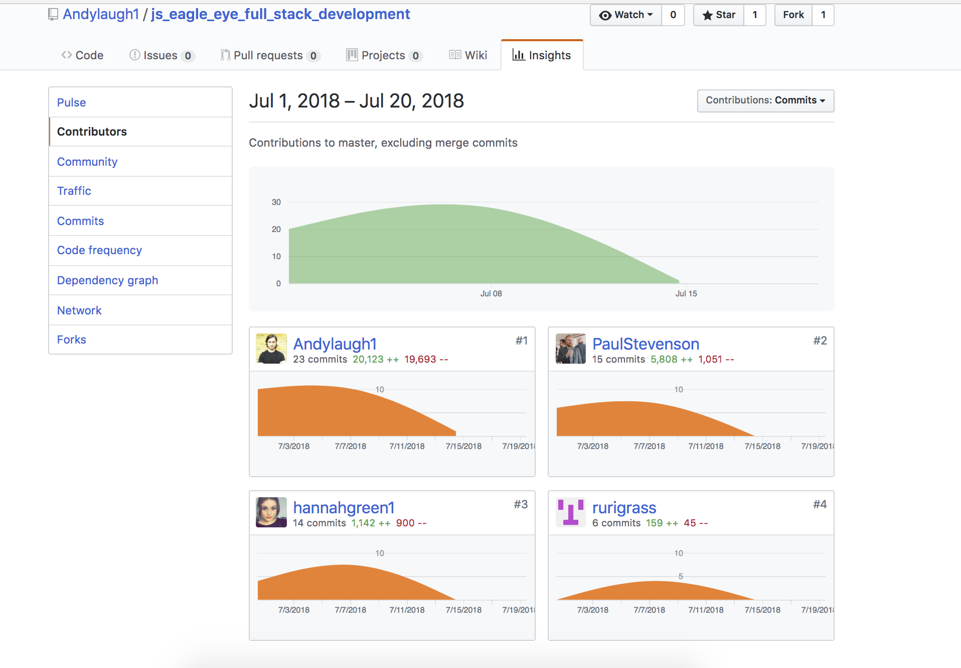

**P 2 Take a screenshot of the project brief from your group project.**

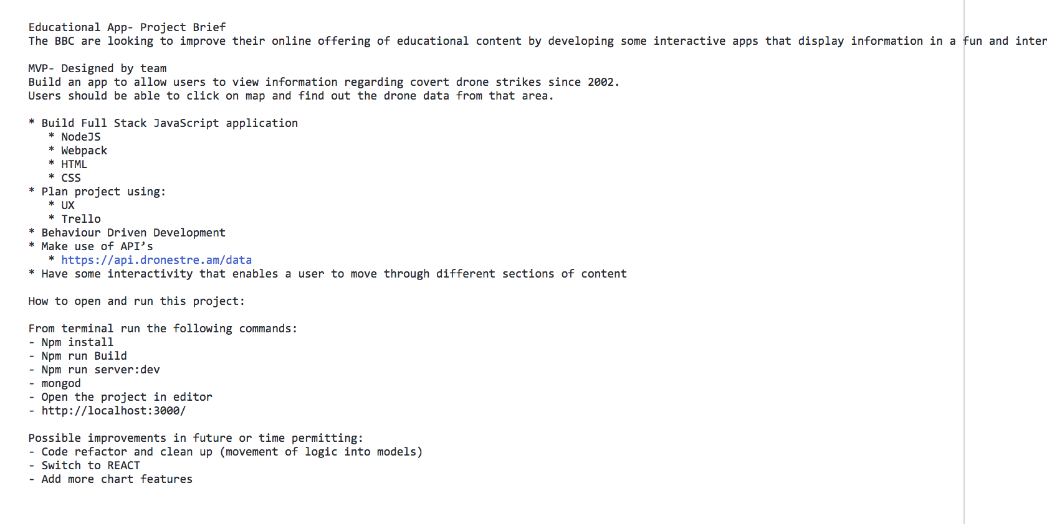

**P 3 Provide a screenshot of the planning you completed during your group project, e.g. Trello MOSCOW board.**

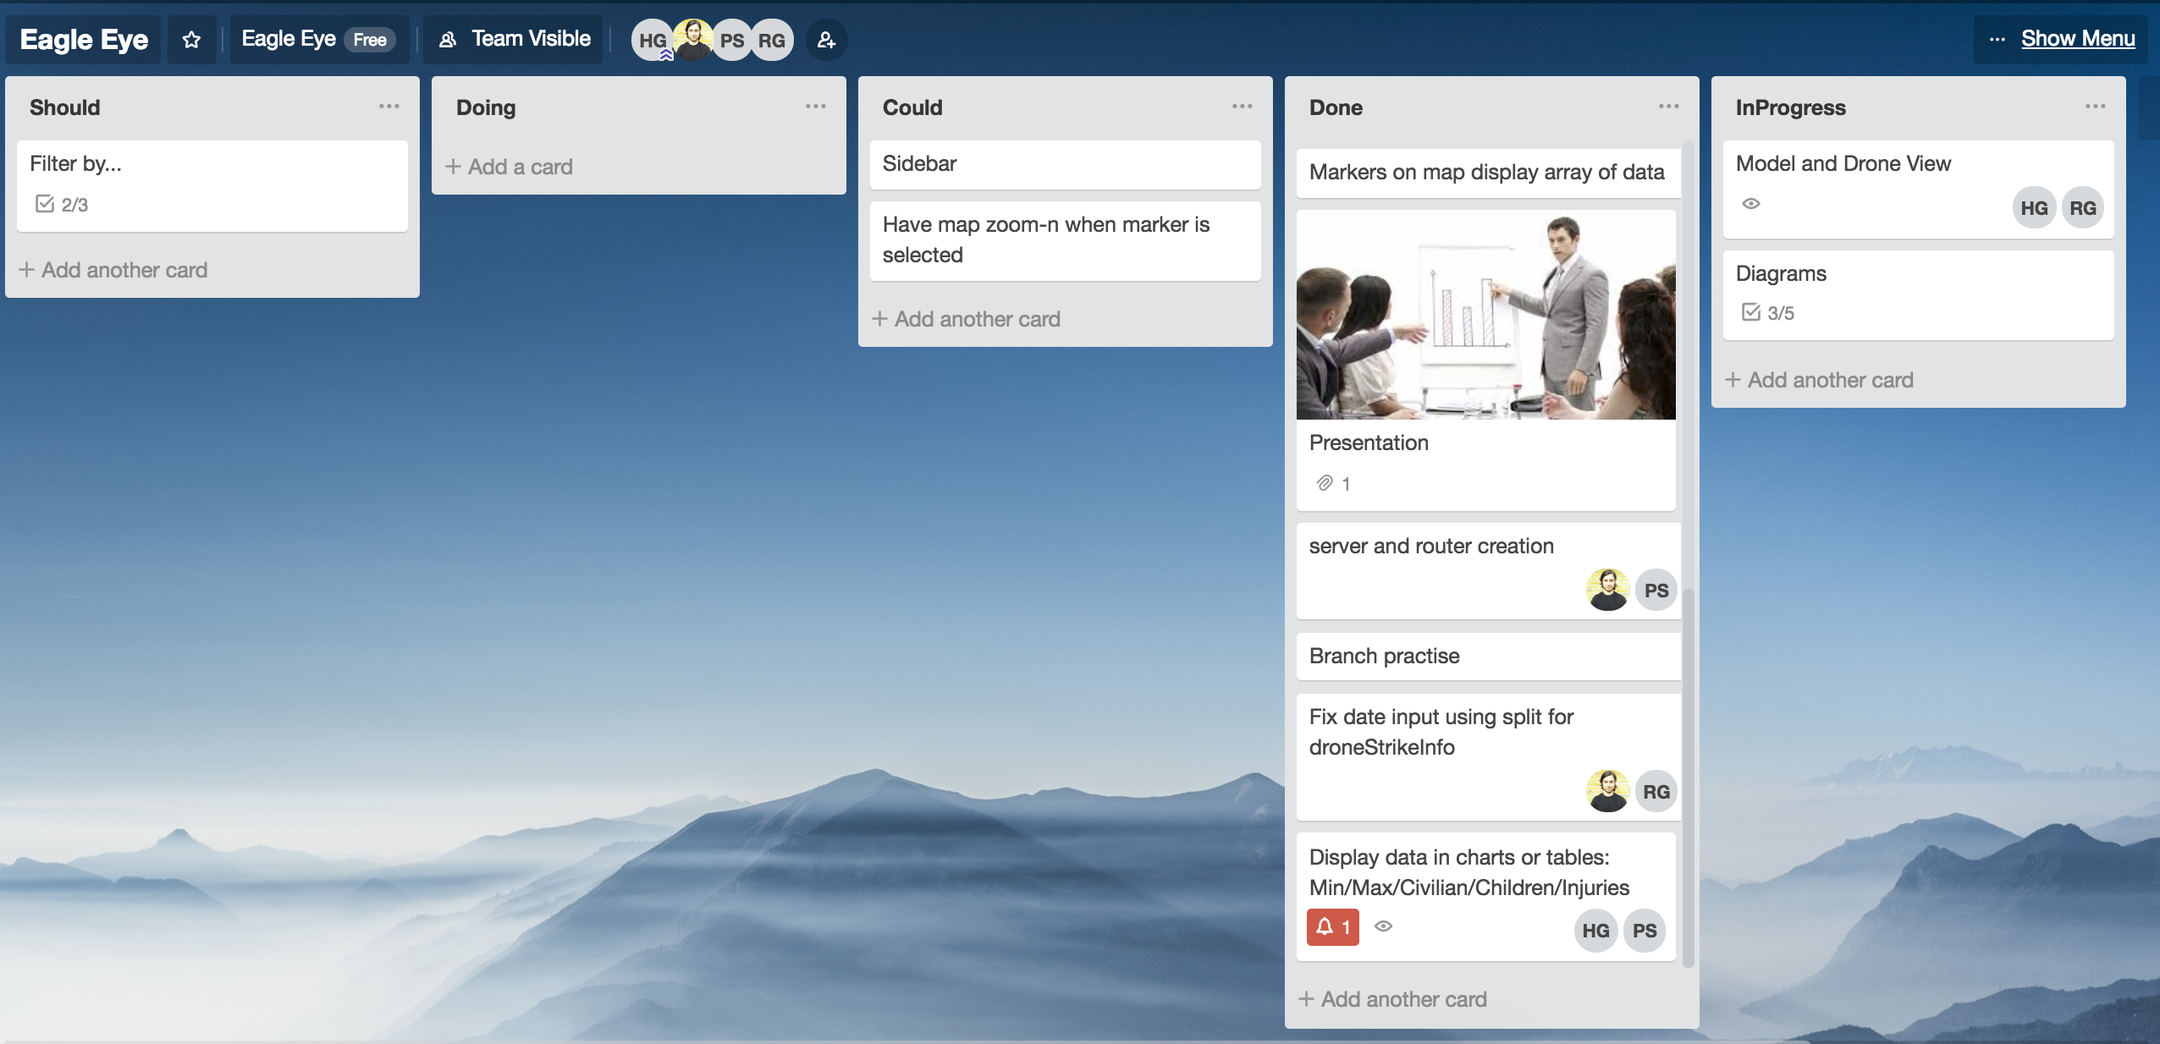

**P 4 Write an acceptance criteria and test plan.**

**P 5 Create a user sitemap.**

**P 6 Produce two wireframe designs.**

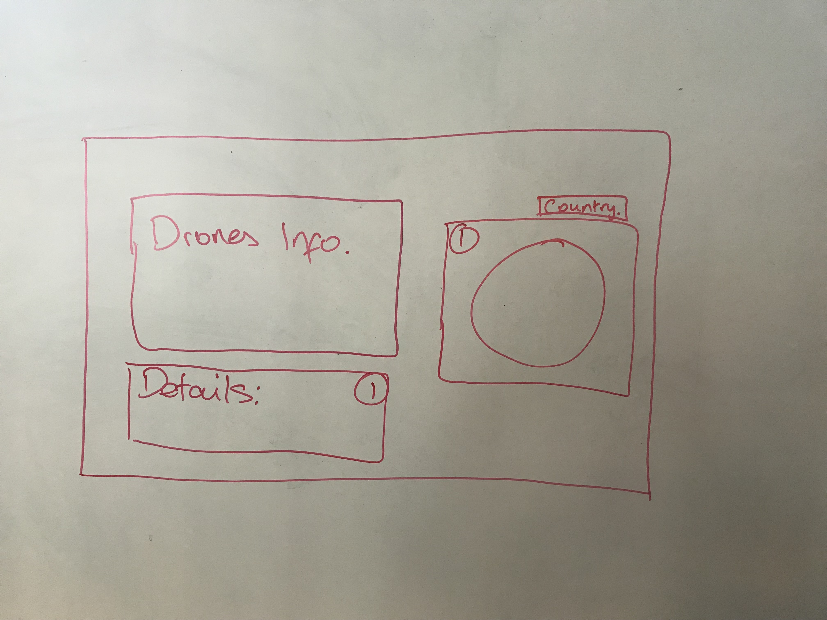

**P 7 Produce two system interaction diagrams (sequence and/or collaboration diagrams).**

**P 8 Produce two object diagrams.**

**P 9 Select two algorithms you have written (NOT the group project). Take a screenshot of each and write a short statement on why you have chosen to use those algorithms.**

**P 10 Take a screenshot of an example of pseudocode for a function.**

**P 11 Take a screenshot of one of your projects where you have worked alone and attach the Github link.**

[**https://github.com/hannahgreen1/Java-Android-Project-Solo-Project**](https://github.com/hannahgreen1/Java-Android-Project-Solo-Project)

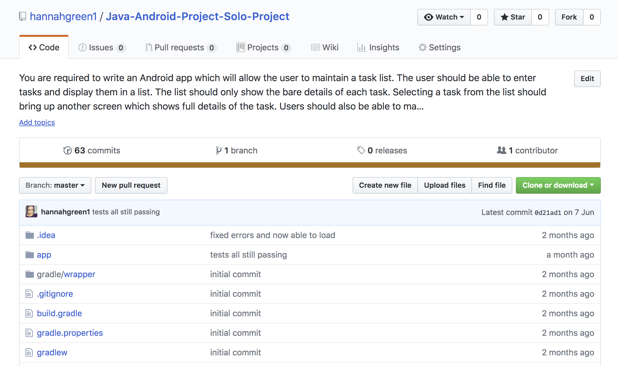

**P 12 Take screenshots or photos of your planning and the different stages of development to show changes.**

**P 13 Show user input being processed according to design requirements.**

● The user inputting something into your program

● The user input being saved or used in some way

**P 14 Show an interaction with data persistence.**

● Data being inputted into your program

● Confirmation of the data being saved

**P 15 Show the correct output of results and feedback to user.**

● The user requesting information or an action to be performed

● The user request being processed correctly and demonstrated in the program

**P 16 Show an API being used within your program.**

● The code that uses or implements the API 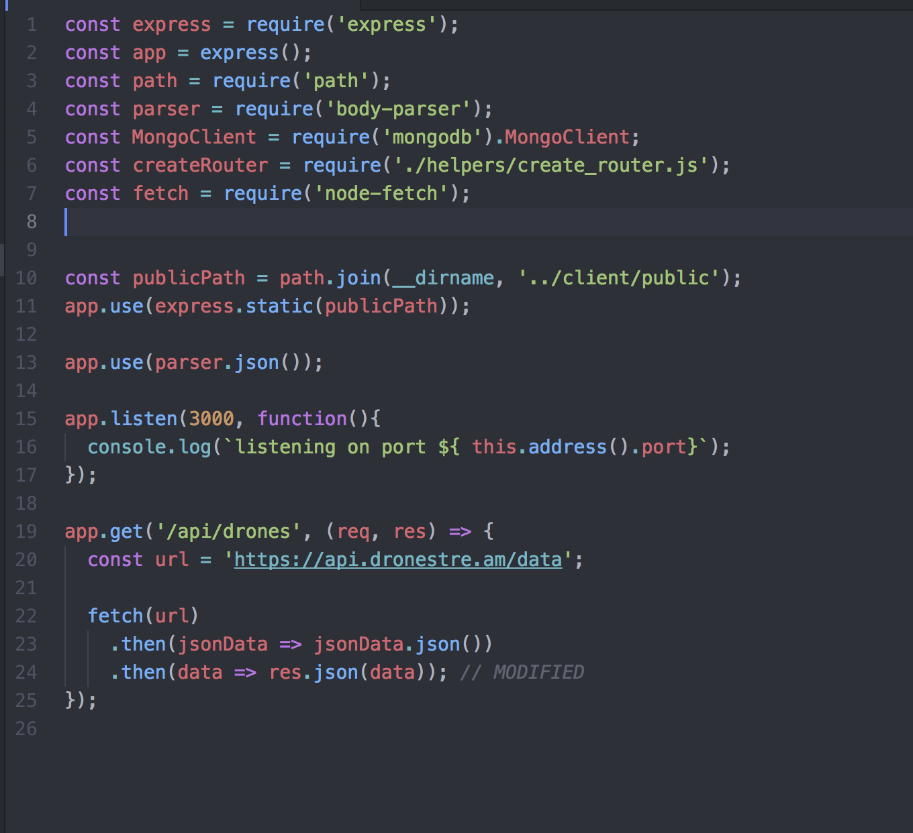

● The API being used by the program whilst running

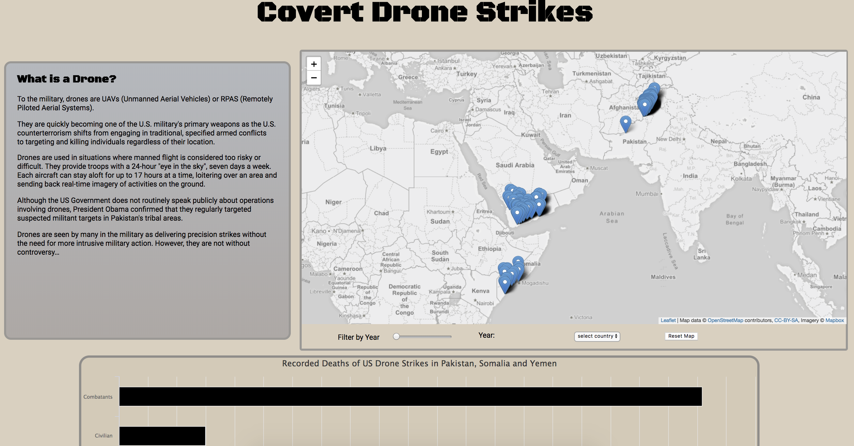

**P 17 Produce a bug tracking report**

**P 18 Demonstrate testing in your program.**

● Example of test code

● The test code failing to pass

● Example of the test code once errors have been corrected

● The test code passing